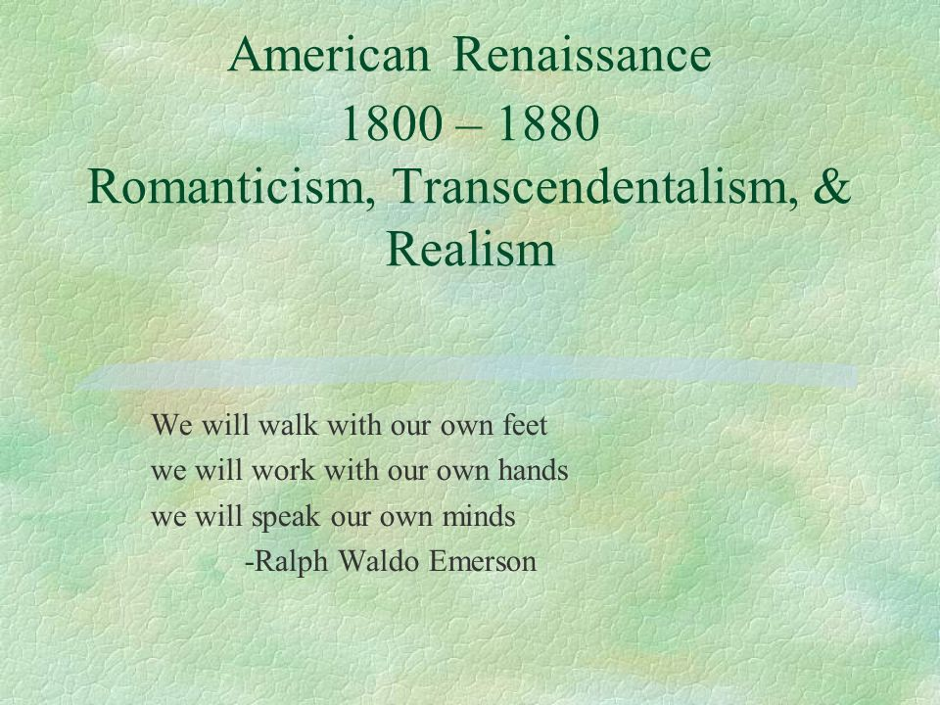

The **Transcendentalist Poem** was a poem of self influence that inspired others to be free and creative instead of following other people's way of life. It showed people thinking for themselves and not doing everything like their family does. The American Renaissance 1800 - 1880 Romanticism, Transcendentalism, & Realism poem is describing doing everything by themselves without others influence on them. This poem shows how during the 1800s it showed self reliance which was important because everyone was trying to follow their own path. This poem in specific really inspires the philosophical belief back then. The message basically is to be free and not listen to others.